Summer Internship Report

### Report submitted in partial fulfilment of the requirement for the degree of



B.Tech.

In

Chemical Engineering Under the Supervision of

IN Charge HRD (Rakesh Kuma r)

By

Sarthak Chugh, Anup Kuma r Jha, Surbhi, Mukul Binjola, Rohit Prasad, Suraj Kuma r, Nivedit Kuma r

To

Delhi Milk Scheme, West Patel Nagar, New Delhi

University School of Chemical Technology Guru Gobind Singh Indraprastha University Dwarka Sec - 16C, New Delhi - 110078

August 2023

ACKNOWLEDGEMENT

I am incredibly grateful to my incharge HRD, Rakesh Kumar, for their invaluable guidance and support throughout my internship. From the moment I started, he took the time to get to know me and understand my goals for the internship. They provided me with clear direction and expectations, and were always available to answer my questions and provide valuable feedback.

I am deeply grateful to Mr. Kuldeep Kumar (ASO), Mr. Dev Narayan (Boiler dept), Mr. Devendar Singh (Refrigeration and air conditioning dept.), Mr. Satish Kumar (Electrical Dept). Mr. Shalindar Pal (Instrument dept.), Mr. Arun Kumar (Mechanical Department) , my mentors and advisors during this internship, for their invaluable advice and guidance. Their industry experience and expertise helped me to better understand the company and the industry, and allowed me to make the most of my internship.

Throughout the internship, they provided me with valuable insights and guidance that helped me to navigate my tasks and responsibilities. They were always available to answer my questions and provide support, and their wisdom and expertise helped me to grow as a professional. I am thankful for their time and support, and for sharing their valuable insights with me.

I am deeply grateful for Delhi Milk Scheme [Organization] support and the opportunity they have provided me. Their financial assistance allowed me to focus on my internship and my professional development, and I am thankful for their commitment to helping me succeed. I hope to continue working with organization in the future and to make the most of this incredible opportunity.

Nobody has been more important to me in the pursuit of this project than the members of my family. I would like to thank my parents, whose love and guidance are with me in whatever I pursue. They are the ultimate role models.

**CONTENT**

* Industry Profile
* Introduction
* Process Section
* Product Section
* Boiler Section
* Refrigeration Section
* Quality Control Laboratory
* Effluent Treatment Plant
* Polypack and Crate Washing
* Electrical Section
* Instrument Section
* Mechanical Section

2

INDUSTRY PROFILE

Delhi Mille Supply Scheme under the India Council of Agricultural Research was underway after the indepen.dence of India to provide milk in Delhi. Delhi Mille Scheme (DMS) was commissioned on· 1 November 1959 to p;ovide milk to the people of Delhi. It was inaugurated by the President of India Rajendra Prasad with the primary objective of supplying wholesome milk to citizens of Delhi at a reasonable price as well as providing remunerative prices to the milk producers. DMS produces ghee, paneer, buttermilk, curd, double-toned, toned, and full cream milk. It was the only organized dairy firm in Delhi at that time. It incurred heavy losses in the 2010s so it was phmned to be leased. It is headed by B. S. Beniwal since October 2010.

The government has decided not to sell milk to Delhites any longer and has instead invited milk cooperatives to run the Delhi Milk Scheme (DMS) - a dairy retail unit started by the first President of India Rajendra Prasad in 1959 - on lease for 30 years.

Union agriculture ministry releasea a bid document for the same on Wednesday. DMS has piled up ·losses of nearly Rs 900 crore and just has a 6% market share in the capital's milk market, but it sits on huge real estate and retail infrastructure in prime areas of Delhi. It could be picked up by Amul brand owner Gujarat Cooperative Mille Marketing Federation (GCMMF) or other prominent milk cooperatives that have shown interest in it in the past, officials said.

As of 2016, DMS sells around 2.70 lakh litres of milk a day. It has 600 booths and 500 other outlets. It has around 149 acres in the national -capital region, Delhi. Its plant is located in West Patel Nagar.

The Delhi Mille Scheme (DMS) plans to set up additional 24 milk booths in slum areas of the national capital. These booths will be constructed in slum areas in colonies such as Lawalpuri, Tilak Nagar, Punjabi Bagh, Tagore Garden, Madipur, Mangolpuri, Sultanpuri, Kalyapuri, Trilokpuri, Dakshinpuri, Khanpur, and Banjara camp in the national capital. The initial instalment capacity of DMS was for processing and packaging of 2.55 lakh litres of milk per day, however, to meet the ever-increasing demand for milk in the city, the capacity was expanded in phases to the level of 5.00 lakh litres of milk per day). This capacity enhancement was for processing and packing one variety of milk i.e. Toned Milk. However,

·as per market demand, DMS started packing of milk in different varieties & *Yi* litlitre litlitre5-

litretrecking.

Products list:

1. Tonned milk:

Toned milk is obtained by the addition o.f water and SMP to whole milk. Under the PFA rules, toned milk should contain a minimum of 3.0% fat and 8.S% SNF throughout the country Toned milk is the brainchild of D.N. Khurody, it was first produced in 1946 in the

<:entral Dairy of Aarer. colony and marketed i.n Bombay city.

Milk

1. Double Tonned milk :

It should contain a minimum of l .S% fat and 9% SNF throughout India.

1. Full cream milk: It should contain a minimum of 6% fat and *95* SNF throughout India.
2. Ghee:

According to PFA rules, ghee is the pure clarified fat derived solely from milk or butter (not table butter) or from cream to which no colouring matter is added.

S. Paneer:

It's a heat cum acid coagulation of casein protein which is present in milk Paneer is a nutritious and wholesome indigenous dairy product that is widely consumed by Indians.

###### Buttermilk:

It is produced by the addition of the same culture which is used in the production of yoghurt

i.e. *Strp. thermophilus* and *Lb. bulgaricus* apart from this pasteurized chilled water is also added, this fermented dairy product is also known as cultured buttermilk.

###### Curd:

DMS produces 2 types of curd- plain and sweet curd. It is produced by bacterial fermentation of milk. The same strains used in buttermilk are used.

INTRODUCTION TO MILK

MILK: Milk may be defined as the whole, fresh, clean lacteal secretion obtained by the complete milking of one or more healthy milch animals, excluding that obtained within 15 days before and 3 days after calving or such periods as may be neoessary to render the milk

* practically colostrum•s fnte and containing the minimwn prescribed percentage of milk fats and SNF, (Milk in technical aspect is defined as the whole, normal, clean and fresh lacteal secretion obtained by milking a healthy animal 72 hours after calving.)

Milk is the primary source of nutrition for young mammals before they can digest other types of food. Milk is a completely balanced food that provides complete nutrition in a balanced proportion and is rich in fats, milk proteins, vitamins, and minerals. The most common animals from which milk is derived include cows, buffalos, ·goats, and sheep. The various types of packaged milk include full cream, skimmed, toned, double-toned, etc., depending on the fat and milk solids content.

FSSAI standards for milk: The FSSAI prescribes specific standards for various types of milk. When milk is offered for sale without indication of the class, the standards prescribed for buffalo milk shall apply.

The standards of different classes and designations of milk are:

|  |  |  |  |  |  |
| --- | --- | --- | --- | --- | --- |
| Class of milk | Designation | Minimum  milk fat | % | Minimum %  milk solid not fat | |
| Buffalo milk | Raw, pasteurized, boiled flavoured, sterilized | 5.0-6.0 | | 9.0 | |
| Cow milk | Do | 3.0-4.0 | | 8.5 | |
| Goat or sheep milk | Do | 3.0-3.5 | | 9.0 | |
| Mixed milk | Do | 4.5 | | 8.5 | |
| Standardized milk | Pasteurized, flavoured and sterilized | 4.5 | | 8.5 | |
| Recombined milk | Do | 3.0 | | 8.5 | |
| Toned milk | Do | 3.0 | | 8.5 | |
| Double toned milk | Do | 1.5 | | 9.0 | |
| Skimmed milk | Raw, boiled, pasteurized, flavoured and sterilized | Not more  0.5% | than | 8.7 | |
| Full cream milk | Pasteurized and sterilized | 6.0 | | 9.0 |  |

#### FSSAI requirements for packaging & labelling of milk:

###### The FSSAI has a stringent set of guidelines for the packaging & labelling of milk, to ensure the best quality and safety of this essential food product for the consumers, many of whom are infants and children.

•Bottling or filling of containers with heat-treated milk shaU be-carried out mechanically and

the sealing of the containers shall be carried out automatically.

•Wrapping or packaging may not be re-used for dairy products, except where the containers are of a type that may be re-used after a thorough cleaning and disinfecting.

•Sealing shall be carried out in the establishment in which the last heat treatment of drinking milk has been carried out. The sealing device shall be so designed that on the container has been opened, the evidence of opening remains clear and easy to check.

•Immediately after packaging, the dairy products shall be pla in the rooms provided for storage.

In case of a package or bottle containing sterilized or Ultra High Temperature treated milk,

soya milk, or, flavoured milk the declaration be made as follows:

"BEST BEFORE: DATE/MONTH/YEAR" OR

"BEST BEFORE: DAYS FROM PACKAGING" OR

"BEST BEFORE: DAYS FROM MANUFACTURE"

In the case of infant milk substitutes and infant foods instead of Best Before a date, Use by date/ recommended last consumption date/expiry date shall be given.

Quality parameters of milk-

When we buy milk, a lot of quality parameters come to our mind either in direct form or indirect form. For example, the property of milk in terms of its composition, mi<:robial load, and freshness are the groups of quality parameters. Another set of quality parameters may be the effect on the environment, ethics, ecology, etc. All these quality parameters affect our acceptability or otherwise for the milk.

Given below is a representation of the different quality parameters of milk affecting consumer acceptance:

* Compositional
* Nutritional
* Sensory
* Cleanliness
* Freshness
* Safety
* Natural
* Biological
* Animal welfare
* Environmental
* Ethical
* Ecological

COLLECTION OF MILK:

In almost all developed dairying countries, the production of milk is confined to rural areas, while demand is mostly urban in nature. Hence, milk must be collected and transported from production points in the milk-shed areas to processing and distribution points in cities.

• •. •.

###### The common systems for the collection (assembling) of milk are as follows:

1. By co-operative organization: Formed by individual or collective milking societies. Suits produoers best as profit-marking king middlemen are involved.
2. By contractors: Less return to producers.
3. By individual producers: Practical for those situated near processing in dairies.

Note: a "milk shed" is the geographical area from which city dairy received its fluid milk supply. The allocation of definite milk sheds to individual dairies to develop the same is now being considered in India.

###### Milk collection cum chilling centres/depots. Normally attached to city dairies. Objects of these are:

To preserve the quality of raw milk supplies, and to provide easy transport to the processing dairy.

###### Location: This is guided by:

1. adequate milk production
2. adequate (potable) water supply
3. proximity to a good road or railway station
4. electric supply and sewage disposal facilities.

###### Major items of equipment:

1. Milk weigh tank/pan and weighing scale
2. Drop (dump) tank with cover
3. Cash washer
4. Milk pump (sanitary type)
5. Surface/plate cooler
6. Refrigerating unit {of suitable capacity);
7. Cold room (of suitable capacity);
8. Milk testing unit, etc.

Operational procedure: Essentially this is the same as in a small dairy. On arrival, the milk is graded for acceptance/rejection, weighed, sampled for testing, cooled, and stored at a IQw temperature until dispatch to the processing dairy.

Cooling of milk: Milk contains some microorganisms when drawn from the udder, their numbers increase during subsequent handling. The common milk microorganisms grow best between 20 and 40°C. Bacterial grows are invariably accompanied by deterioration in market quality due to the development of off-flavours, acidity, etc. One method of preserving milk is by prompt cooling to a low temperature.

Milk plate Chiller: To maintain the quality of milk received in the Dairy/Chilling Centre, it

is chilled to 4°C by a milk chiller. The chiller consists of stainless steel plates. Chilling is done by flowing milk from one side and chilled water from the other side of the plates.

DELID MILK SCHEME

MILK PROCESSING PLANT

Milk Reception: Dairies have special reception departments to handle the milk bought from

the fanns. The first thing done at reception is to determine the quantity of milk. The quantity is recorded. and entered into the weighing system that the dally uses. to weigh the intake and

compare it with the output. The quantity of intake can be measured by volume or by weight

Key Features:

* + Plant capacity is *5* LLPD
  + Tanker reception
  + Weighing bridge
  + Platform test
  + Milk collection by tankers

FLOW DIAGRAM OF THE PROCESS OF RECEIVING MILK TANKERS ARRIVAL

# l

SECURITY CHECK

TANKER\NTRY AND DOCUMENTATION AT RECEPTION WEIGHJo OF TANKER

# l

PLUNGING OF RAW MILK

# l

PLATFORM TEST

UNLOAD G TANKER

# l

CLEANING TANKER

Flow chart description:

Tankers: Tankers arriving at the Delhi Milk Scheme from different cooperative dairies. The raw milk arrives at the dairy in insulated road tankers. The milk must be kept well chilled, free from air, and treated as gently as possible. For example, tanks should be well-filled to prevent the milk from sloshing around in the container. Tankers are made up of 304-grade stainless steel material and their capacity is 15000-28000 L. DMS has done agreements with some cooperative dairies/private dairies for raw milk supply.

Security check: Security officers check out the tanker and match the tanker number with their documents and note down the tanker number and driver name then the tanker is over to the reception. They also check the proper sealing on the tanker.

Tanker entry and Documentation: Tanker driver notes down reaching time at DMS, tanker number, and dairy name at reception. The receptionist in charge match their dairy documents

whic mentioned the timing of loading milk, the temperature of milk, the acidity of milk, the quantity of milk(weight), the Fat/SNF of milk, and pH the of milk.

Weighing: Weighing the tanker before and after unloading and then subtracting one value from the other. The· automatic weighing achine's capacity is 40 Tons. At the time of weighing tanker should not have any extra material or item inside it. The weight the of tanker with the milk. is known as Gross weight...When the gross weight of-the tanker has been recorded, the milk is delivered to the dairy. When empty, the tanker is weighed again and the tare weight is deducted from the previously recorded gross weight.

Gross weight - Tare weight = Net weight

The plunging of raw milk: Before sampling raw milk, plunging of raw milk in a tanker is done with the help of a plunger for 20 to 30 minutes for proper mixing of SNF and Fat.

Platform tests: The temperature of the milk is taken the by QCL department and an organoleptic test is also done. The sampling of each tanker is in 500 bottles tiles and there should be separate marks of tanker number on bottles. Take two· samples A & B then platform testing is done. After passing the milk sample tanker proceed for unloading.

9

*(*

###### PROCESS SECTION FLOW DIAGRAM OF RAW MILK PROCESSING

Raw milk stmage tank Pump

Balanfe tank Flow co .01 valve

Regeneratio I (40 to 45C) F er

###### Regeneratio!il(60 to 65 C) Final heatin (70 to SOC) Booster pump

•

Hold!g tube

Flow diversio valve (FDV) Regeneltion II Regene tion II

Chilling Jtion (4C)

Chillerf 1-2C)

sfo

###### Pasteurized milstorage tank

Raw Mill< Storage Tank (RST): The untreated raw milk (whole milk) is stored at 4°C in horizontal tanks called RST which have capacities of 14000 litres. RSTs are often located indoors. RSTs are of double-wall construction, with insulation between the walls. RST is made of stainless steel material.

Balance Tank: The float-controlled inlet valve regulates the flow of milk and maintains a constant level in the balance tank. If the supply of milk is interrupted, the level Will begin to drop. As the pasteurizer must be full at all times during the operation to prevent the product from burning onto the plates, the balance tank is often fitted with a low-level electrode that transmits a signal as soon as the level reaches the minimum point. This signal actuates the

10

ow diversion valve, which returns the product to the balance tank. The balance tank is often a recirculating system where the liquid is returned for recycling eg, as a result of msufficient heat treatment. In this case, a temperature indicator actuates a flow diversion valve, which directs the product back to the balance tank. This causes a quick increase in the liquid level and an equally quick movement of the float mechanism to close the inlet valve. The product then circulates until the fault has been repaired or the plant is shut down for adjustments. A similar.procedure is employed for circulating cleaning solution when the line

is cleaned.

Flow control valve: In the regulating valve, the passage can be changed gradually. The control valve is used for accurate c0ntrol of flows and pressures at various points in the system. When the regulation handle is turned, the plug moves up or down varying the passage and thereby the flow rate or the pressure.

Feed pump: The feed pump supplies the pasteurizer with milk from the balance tank which provided a constant head.

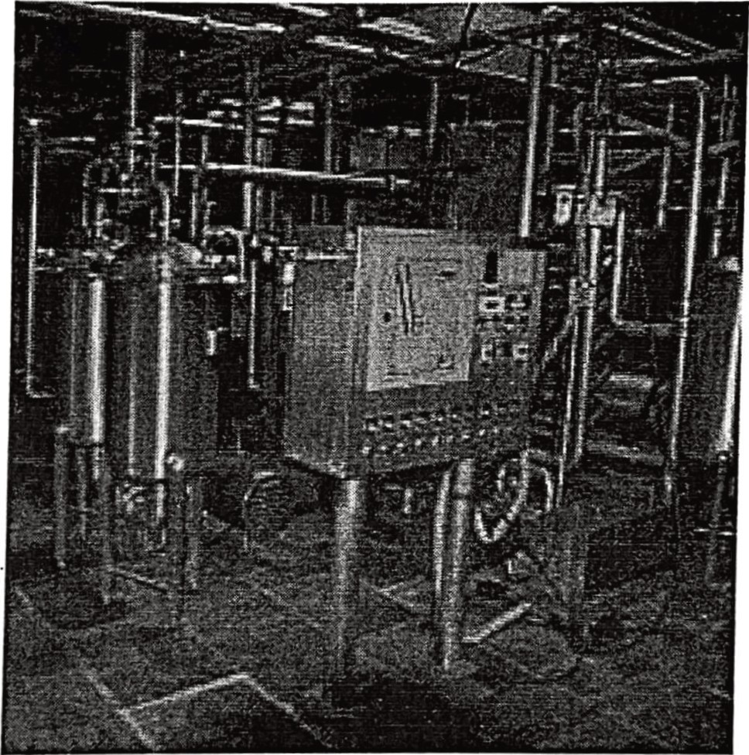

###### PASTEURIZATION-

Definition: Pasteurization or a process in which certain packaged and non-packaged foods (such as milk and fiuit juice) are treated with mild heat, usually less than 100 "C (212 °F), to eliminate pathogens and extend shelf life. The process is itended to sterilize foods by destroying or inactivating organisms and enzymes that contribute to spoilage, including vegetative bacteria, but not bacterial spores. Since pasteurization is not sterilization and does not kill spores, a second "double" pasteurization will extend the quality by killing spores that have germinated.

The process was named after the French scientist Louis Pasteur, whose research in the 1880s demonstrated that thermal processing would inactivate unwanted microorganisms in wine.

11

###### HTST asteurization- HTST is the abbreviation of High-Temperature Short Time. The actual time/temperature combination varies according to the quantity of the raw milk, the

!YJ>es of product treated, and the required storage properties. The HTST process for milk involves.heating it to 78-80°C with a hold of 15 seconds before it is cooled. The phosphatase enzyme is. destroyed by this time/temperature combination. The phosphatase test is therefore used to <:heck that the milk has been properly pasteurized. The test result must be negative,

•·there must be no detectable.phosphatase activity. •. .

e asteurization process in DMS is of HTST type i.e. high temperature short time, where milk Is heated at 72°C for only 15 seconds. The indicator organisms for the pasteurization are Mycobacterium tuberculosis and Coxiellaburnetti as they are the most heat-resistant pathogens to be eliminated in the process and thus in pasteurized milk, these organisms

shoud be absent. If not eliminated, they indicate that the pasteurization process is not efficient

Purpose of heat treatment (Pasteurization):

1. To destroy as y as possible of microorganisms and enzymatic systems. This requires more intense heat treatment than is needed to kill the pathogens.
2. To render milk safe for human consumption by destruction of pathogenic bacteria.
3. To improve keeping the quality of milk by the destruction of almost all spoilage organisms (89- 99%).

Formulations of standards of pasteurization: _

The following considerations were involved in the formulation of the standards of pasteurization-

!. Regenerative pre-heating- The cold untreated milk is pumped through the first section in the pasteurizer, the pre-heating section. Here, it is regeneratively heated with pasteurized milk, which is cooled at the same time. Ifthe milk is to be treated at a temperature between the inlet and outlet temperatures of the regenerative section, for example, clarification at SS°C, the regenerative section is divided into two sections. The first section is dimensioned so that the milk leaves at the required temperature of 55°C. After being clarified, the milk returns to the pasteurizer, which completes the regenerative pre-heating in the second section. The regenerative energy-saving effect in milk pasteurizers is typically between 90-94%.

1. Filtration- Filter units to connect directly to the HTST system are placed after the preheater or regenerative heating section. The milk filter conists of a nylon filter bag or a filter pad supported on perforated stainless .steel. Milk usually passes from top to bottom. These units are cylindrical in shape. Usually, two filters are attached but one is used at a time. This permits continuous operation, the flow being switched from one to another while replacing a filter and it is needed to remove dust particles or foreign particles from milk so raw milk can be pasteurization properly.

III Final heating section- Final heating to pasteurization temperature with hot water normally of a temperature 2-3°C higher than the pasteurization temperature takes place in the heating section. The hot milk continues to an external tubular holding cell. Steam is delivered from the steam boiler at a pressure of 600-700 k.Pa (6-7 bar). This steam is used to heat water, which in tum heats the product to pasteurization temperature.

IV. Bolding tube- The hot milk continues to an external holding tube through the booster pump. l5s milk held in the holding tube at 78°C. After the holding cell, the temperature of the milk is checked by a sensor in the line. It transmits a continuous signal to the temperature controller in the -control panel. The same signal is also transmitted to a EeCOrding instrument that records the pasteurization temperature.

JI. Flow diversion valve (IDV)- A sensor after the holding cell transmits a signal.to the temperature monitor. As soon as this signal falls below a pr-e-set value, corresponding to a specified minimum temperature, the monitor switches the flow diversion valve to dicect the flow. The flow diversion valve is situated just after the holding tube. Ifthe temperature drops under the pre-set level, the valve diverts the flow to the balance tank and the pump stops.The flow in the regenerative and cooling sections thus comes to a standstill. After a short while, without a temperature increase, the heat exchanger is emptied, cleaned, and sanitized. When satisfactory heating is possible, the plant is.restarted.

1. Chilling section- After the holding section, the milk is returned to the regenerative sections for cooling. Here the pasteurized milk transfers its heat to the cold incoming milk. The outgoing pasteurize milk is then chilled with cold water. 11le temperature of the chilled milk is noonally

recorded, together

with the Mlk-tn

I

I08W81ef Water 1 Regenitudlve

t:

* + cidollng_._ cooing

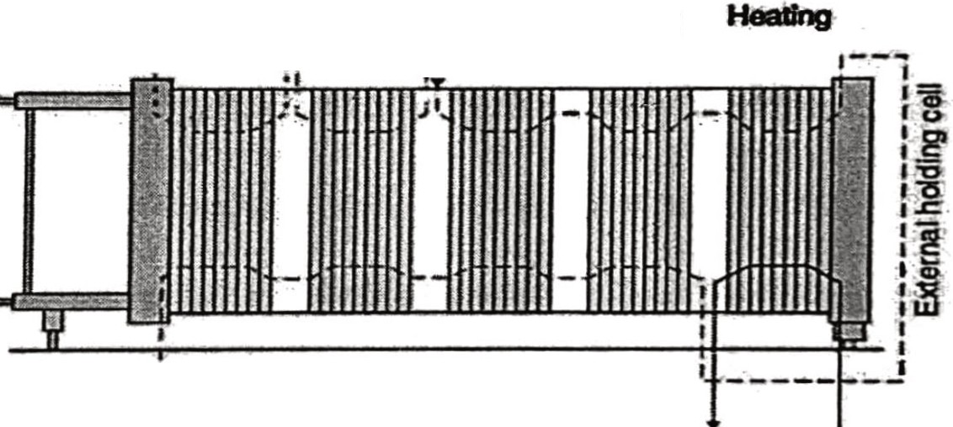

• :1 I

* I'

I

'-

Mllki>.Pt

-······QHolilt.-lwedater

- - ·Welt

water

----Milk

pasteurized milk temperature.

###### Simple five-stage pasteurization process of milk

Clarification and cream separation (centrifugal separator)

Prin.<:iples of Centrifugation • .. . Centrifugation is based on 'Stroke's law. The particle sedimentation velocity increases with:

* + • Increasing diameter
    - Increasing difference in density between the two phases
    - Decreasing viscosity of the continuous phase

Ifthe raw were allowed to stand, the fat globules would begin to rise to the milk surface in a phenomenon called creaming. Raw milk in a rotating container also has centrifugal forces acting on it. This allows rapid separation of milk fat from the skim milk portion and removal; of solid impurities from the milk.

CLARIFICATION- In a centrifugal clarifier, the milk is introduced into the separation channels at the outer edge of the docs stack, flows radially inwards through the channels towards the axis of rotation, and leaves through the outlet at the top. On the way through the disc stac1:c, the solid impurities are separated ad thrown back along the undersides of the discs to the periphery of the clarifier bowl. There, they are collected in the sediment space. As the milk passes along the full radial width of the discs, the time of passage also allows very small particles to be separated. The most typical difference between a centrifugal clarifier and a separator is the design of the disc stack. A clarifier gas has distribution holes or open holes at the periphery. The number of outlets also differs- a clarifier has one and a separator has two.

SEPARATION- Centrifuges can be used to separate the cream from the skim milk. The centrifuge consists of up to 120 discs stacked together at a 45-60-degree angle and separated by a 0.4-2.0 mm gap or separation channel. Milk is introduced towards the inner edge of the disc stack. The stack of discs has vertically aligned distribution holes into which the milk is introduced.

The disc stack is equipped with vertically aligned distribution holes in a centrifugal separator. The milk is introduced through vertically aligned distribution holes in the discs at a certain distance from, the edge of the disc stack. Bowl discs used revolve at rpm of 5500-6000 and separate milk at a mass flow rate of 20,000 l/h. Under the influence of centrifugal force, the sediment and fat globules in the milk begin to settle radially outwards or inward in the separation channel, according to their densities relative to that of the continuous medium (skim milk). The cream i.e. the fat globules has a lower density than the skim milk and therefore moves inwards in the channels, towards the axis of rotation, and the cream continues to man axial outlet. The skim milk moves outwards to the space outside the disc stack and from there through a channel between the top of the disc stack and the conical hood of the separator bowl to a concentric skim milk outlet.

CREAM STORAGE TANK (CST)- DMS has four cream storage tanks, each with a capacity of 4000 liters. The cream is stored at 4°C in horizontal tanks called CST. CST is often located indoors. CST is double-wall construction with insulation between the walls. CST is made up of stainless steel material.

LR- .Chilcrs ore required to hnve cooler milk for *a* better shelf life of milk. An tank ?na chiler is attached to the pipeline after the pasteurization tank and before the silos mtenned1ate temporary milk storage tank). Extra chiller decreases the milk temperature

to beI

ow 4°C.

0

SILO (

.mtermediate temporary storage tank)- These tanks are used to store a product for a sort .time before it continues along .the line storage. After heat treatment and cooling, the milk is pumped into a silo tank and from there to filling. If the filling is intenupted, the process milk is buffered in the tank until the operation can be resumed. Similarly, milk from this tank can be used during a temporary processing stoppage.

In .storage tanks with a capacity of 60,000 to I00,000 litres, the inner shell is made of stainless steel. The tank is insulated to maintain a constant product temperature. In this case, the outer shell is also of stainless steel and there is a layer of mineral wool between the shells. The storage tank has an agitator and can be fitted with various components and systems for clng and control of level and temperature. This equipment is the same as PST tanks which are further described.

In DMS there are S silo tanks, 4 silo tanks of capacity 100,000, and l silo tank of capacity 60,000 litres.

STANDARDIZATION- Standardization of milk ref to the adjustment ie, raising or lowering of the fat and/or solid-not-fat percentages of milk to a desired value. In the market milk industry, this normally involves reducing the butter fat content by the addition of skim milk or through the removal of the cream. Milk standardization is important in the dairy industry because it is used to ensure that every consmner gets milk with constant fat content and consistency. P_rimarily, milk may be separated into. two products; cream with a high-fat content (about 40%fat) and skimmed milk (about 0.03% fat) using a centrifugal separator. The process of standardization involves the reduction of fat content in milk from the natural minimum of 3.25%. The cream extracted from the standardization process facilitates the processing of other dairy products such as ice cream, butter, and ghee. Milk standardization can take two forms ie, either partial separation or mixing of skimmed and whole milk. Mass balancing plays a key role in the successful standardization of milk. Raw milk received at DMS has a wide range of fat & SNF content i.e. 6.5%-7.0% fat & 8.8-9.1% SNF. This must be standardized to 3.05% fat and 8.6% SNF for toned milk, for double toned it is I.SS% fat and 9.0% SNF and for full cream milk, it is 6.05% fat and 9.1% SNF.

Milk standardization using Pearson's square method

The square is drawn and then the immediate constituent content is placed at the centre, which in this example is fx. Place the higher constituent content (fw at the left-hand side top comer and the lower constituent content at the left-hand side bottom comer). Subtract diagonally the higher value from the smaller value as illustrated in the figure below:

15

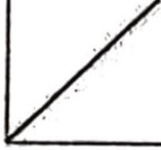

r.;..

+·



Pearson's square



###### The sum of the values on the right-hand side of the square equals the value at the top left minus that at the bottom left ·side and this value represents X. The value at the top right represents W and the value at the bottom right represents S. From the values, we can calculate the proportions of W and S, Pw and Ps respectively in X. Pearson's Square is ideal for use when we have to use two streams/substances to standardize one constituent.

PASTEURIZATION MILK STORAGE TANK (PST)- After the sample passing, milk is transferred from the silo to PST. The milk is stored at 4°C in horizontal tanks called PST which have capacities of 14,000 liters. PST is often located indoors. PST are double-wall construction, with insulation between the walls. PST is made up of stainless steel material. There are a total of 12 PST in the Delhi milk scheme.

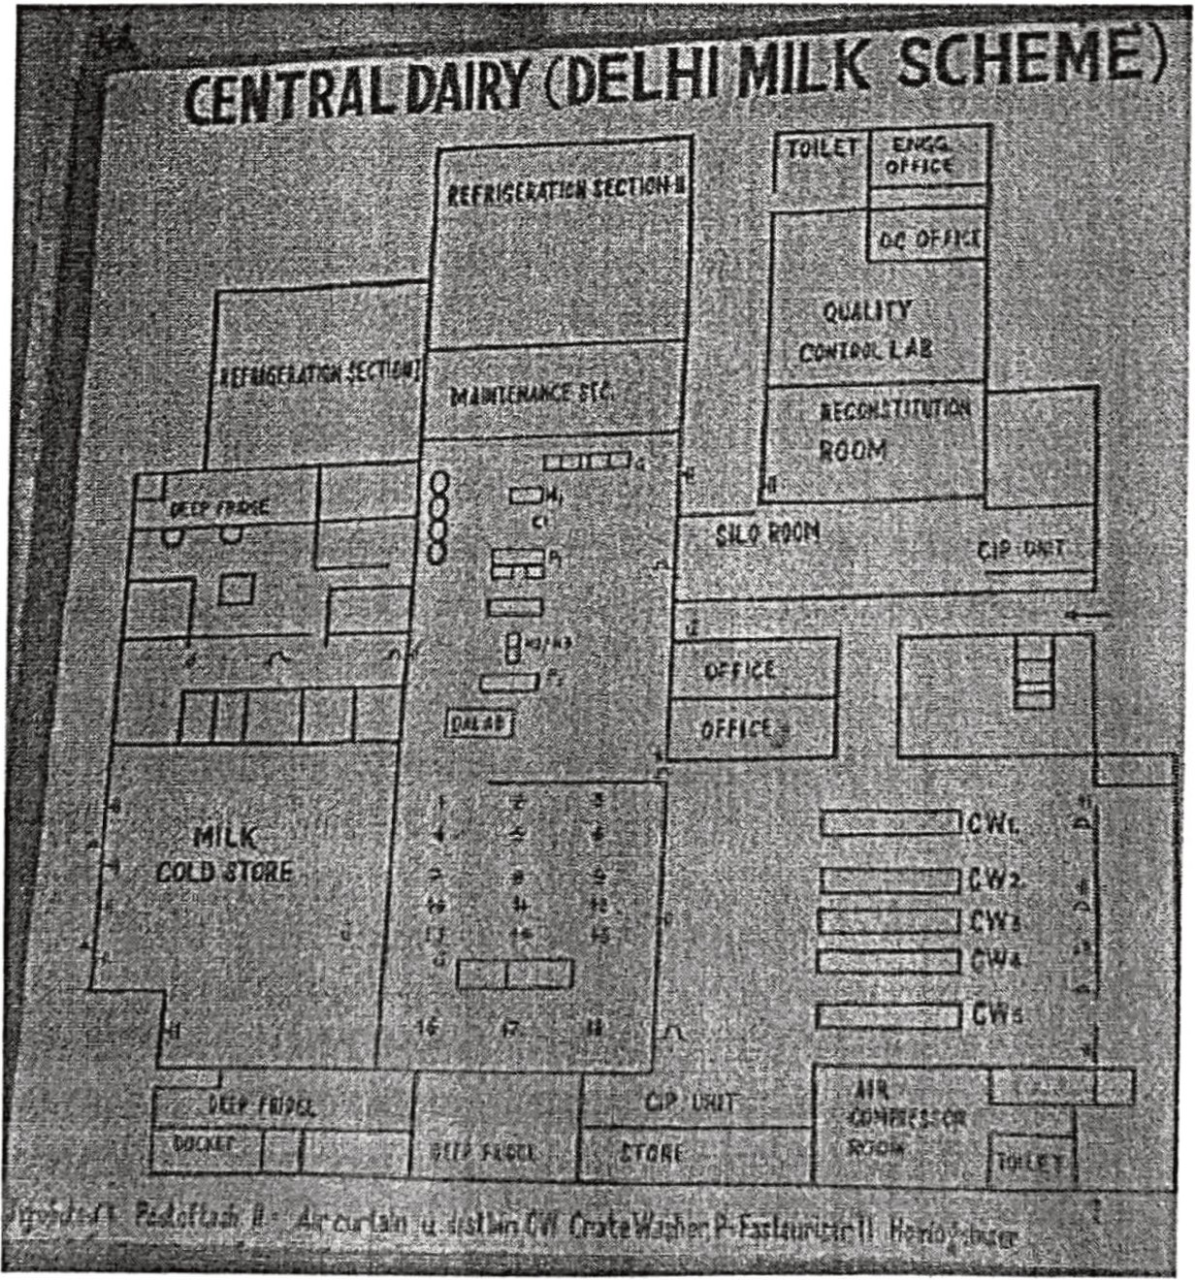

16

###### PRODUCT SECTION

THE FOLLOWING ARE THE MILK PRODUCTS OF DMS:

* + - 1. PANEER
      2. DAHi

3. CHHACHH .

4. GHEE

5. BUTTER

PANEER: Paneer is a heat-acid coagulated milk product obtained by coagulating standardized milk with the permitted acids at a specified temperature. The resultant coaguluin is filtered and pressed to get the sliceable curd mass. Paneer has a firm, close, cohesive, and spongy body, and smooth texture. Paneer can also be defined as the product obtained from cow or buffalo milk or a combination thereof by precipitation with sour milk, lactic acid, or, citric acid. It shall not contain more than 70.5% moisture and milk fat content shall not be less than 50% of the dry matter. Milk solids may also be used in the preparation of paneer.

###### FLOW CHART FOR PANEER MANUFACTURING:

•

Raw milk

Milk Standardization •(Fat: SNF I :1.65 to 1.75) Cooling of milk vat till 70°C

Heating•at 85°C

•

Adding citric acid solution (I - 2 %) with constant stirring Coagulum\f milk

Filtration with *l* muslin cloth

•

•

Pressing under hydraulic pressure (110 psi for 20 rains) Paneer is kept in cold water at 50°C for 3 to 4 hours Cutting and tackaging

•

store at 50°C

Cold

Dispatch

18

DMS Paneer:

###### Net Weight: I kg and 200g

Storage conditions: Keep in a cool place

Date of Expiry: Best before 14 days from packaging.

.. CURD/DAHi:

Dahi or curd is a product obtained from pasteurized or Boiled milk by souring, natural or otherwise by harmless lactic acid. It is a fermented product.

There are two types of dahi manufactured in DMS

I) Plain Dahi (Prepared with double-toned milk)

* + 1. Sweet Dahi (Prepared with toned milk)

Following Cultures used for the curd formation: Streptococcus thermophiles and lactobacillus bulgaricus

FLOW.

CHART OF DAHi MANUFACTURING

##### PLAIN CURD/DAHi-

###### Double Toned Milk is taken Milk is heated at 78°C Passed fr chiller 47°C

Addition of culture (2%) at 43-44°C

Packaging (filling in'

cups, capping, sealing)

###### Placing in an incubation room at 470°C

.

(It provides favourable conditions for bacteria to grow) Formation of cu (in 2 - 2.5 hours)

Place in Cold storage (3 -40°C)

SWEET CURD/DAHi:

###### Toned Milk is taken Addition of sugar (8%) Milk is heated at 78°C Passed fro!chiller 47°C

'

Addition of culture!%) at 43-44°C Packaging{filling iJcups, capping, sealing)

Placing in an incubation room at 47°C

(It provides .favourable conditions for bacteria to grow)

Formation of'curd (in 2 - 2.5 hours)

###### DMS Curd/Dahl:

Place in Cold'

storage (3 -4°C)

Net weights: 100 g{sweet curd) and 200 g (plain curd)

Storage conditions: keep in a cool place

Date of expiry: Best before 5 days from packaging

###### CHHACHH CBUITERMILK): .

It refers to buttermilk, which is a by-product obtained when churning curdled whole milk with crude indigenous devices for the production of desi butter.

Homogenized toned milk is used for the production of chhachh.

###### FLOW CHART FOR CHHACHH MANUFACTURING

Toned milk is taken Milk is heated at 78°C

Cooled at 48°C inLes(40 kg milk)

Addition of culture (2%)

Incubation for 2-2.5 hours at 45-48°C

After incubation kept in a cold'

room at s0c for the whole night

The next morning dahi canes @re transferred to'

the Chhachh balance tank

Addition of water in curd

Mixing of curd and water w the help of a plunger

Addition of jeera (0.35%'

) and salt (0.65%)

(Jeera is added in roasted and powdered form)

Mixing with the heJ of a plunger

•

Passed through the chiller

Packaging is done at 4°C (horizontal and vertical sealing)

###### Store and dispatch

DMS Chhachh:

Net weight: 200 ml

Storage condition: Keep in a cool place Date of expiry: Ifstorea at below 6°C then it can be used for 6 days from packaging.

###### GHEE:

According to the Food Safety and Standards Authority of India (FSSAQ, ghee means the pure clarified fat derived solely from milk or curd or from desi cooking) butter or from cream to which no colouring matter or preservative has been added.

###### FLOW CHART FOR GHEE MANUFACTURING:

White butter

Melting of white butter in a melting vat (80°C) Melted butter is placed in *f*gitator tanks via pipelines

Agitation and heatin!at 112°C for 2 hours Filtration with nylon filter (un anted materials are removed)

Ghee clarifier (since ghee is heated at l 12°C for 2 hours, the formation of brownish The particle takes place that is needed to be removed)

'

Balance tank store Packaging and s rage (40-41°C)

DMS Ghee:

Net Quantities: 1 litre and 500 ml Storage condition: Keep in a cool and dry place Date of Expiry: Best before 10 months from packaging.

###### BUTTER:

Butter may be defined as a fat concentrate, obtained by churning cream, gathering the fat into a compact mass, and then working it. As per FSSAI (2011), Butter means the fatty product derived exclusively from the milk of cow and/or buffalo or its products principally in the form of a water-in-oil type of emulsion. The product may be with or without added common salt and starter cultures of harmless lactic acid and/or flavour-producing bacteria. Table butter shall be obtained from pasteurized milk

cl/or ther milk products which have undergone adequate heat treatment to ensure crob1al safety. It shall be free from animal body fat, vegetable oil, and fat, mineral

oil & added flavour. It shall have a pleasant taste and be flavour-free proof-flavourful and rancidity. It may contain food additives permitted in these Regulations. It shall conform to the microbiological requirements of the regulation.

FLOW CHART FOR BUTTER MANUFACTURING:

Cream Sto..r.age tank

*err*

The cream is placed in a churner for 2 hours (1800 -2000 rpm)

Added colour (aitto) 1.8% of fat % in cream

. Ch1f for 20-25 mins

Churner separates butter and whey protein Fo ation of butter

•

•

Whey protein was drained and transferred to the return tank Washing butter in cold water

•

•

Added salt and 2% of butter Chum again (salt mix in butter properly)

•

Samjling

Manually separated in trolley (temp. in trolley 4 -s0c)

•

Packaging (after 12 -14 hours) Stored at -l 8°C

•

##### DMS Butter:

Net quantities: *500* gm (both white and salted table butter) Storage condition: Keep in a cool place.

Date of expiry: Used before 12 months when kept at -18°C

**BUTTER** (Salted and White Table Butter)

·-

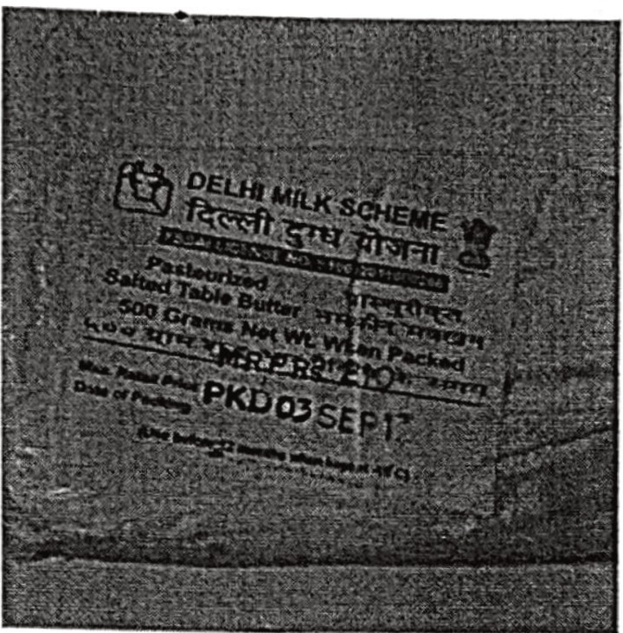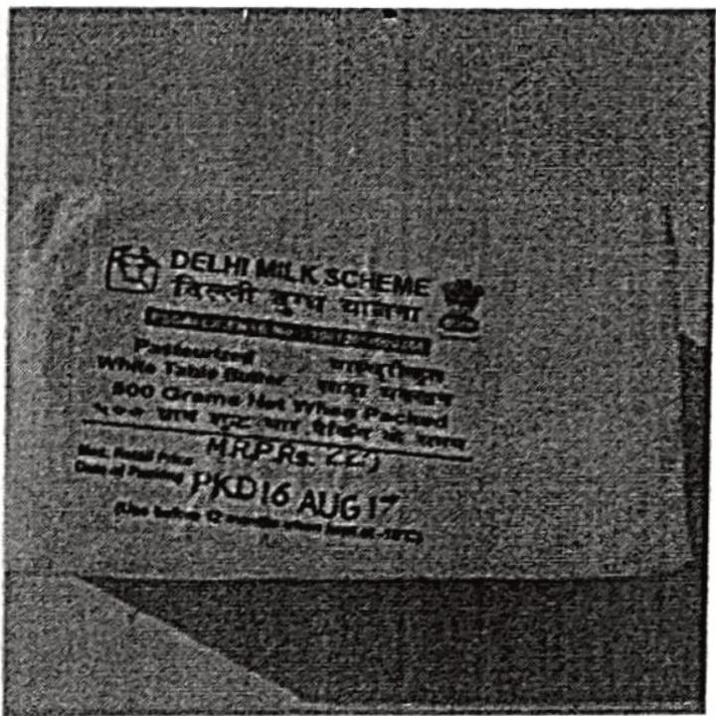



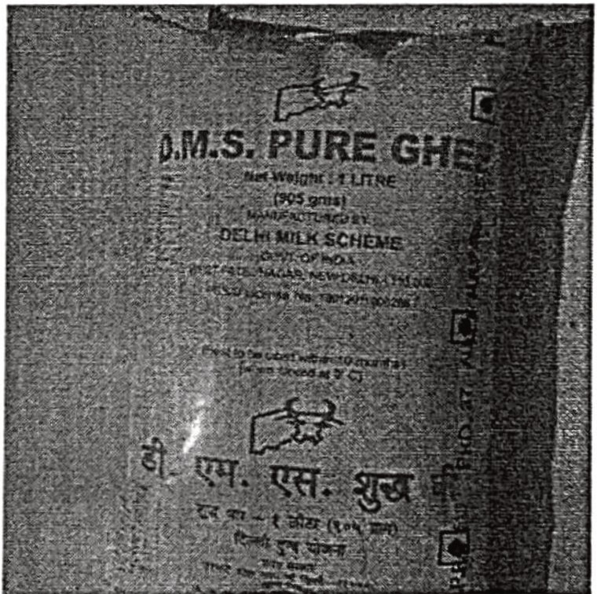

DAHi (Plain and Sweet Dahi)



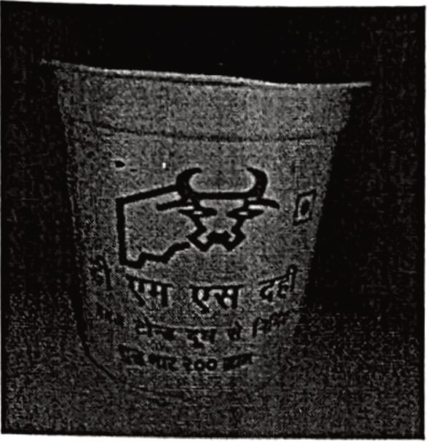 •. 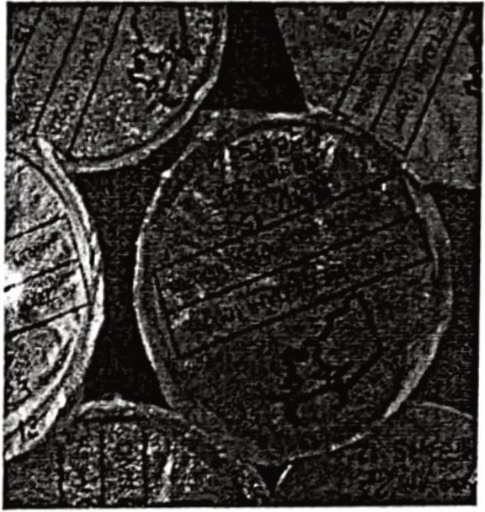

CHAACHH (Plain and Masala Chaachh)

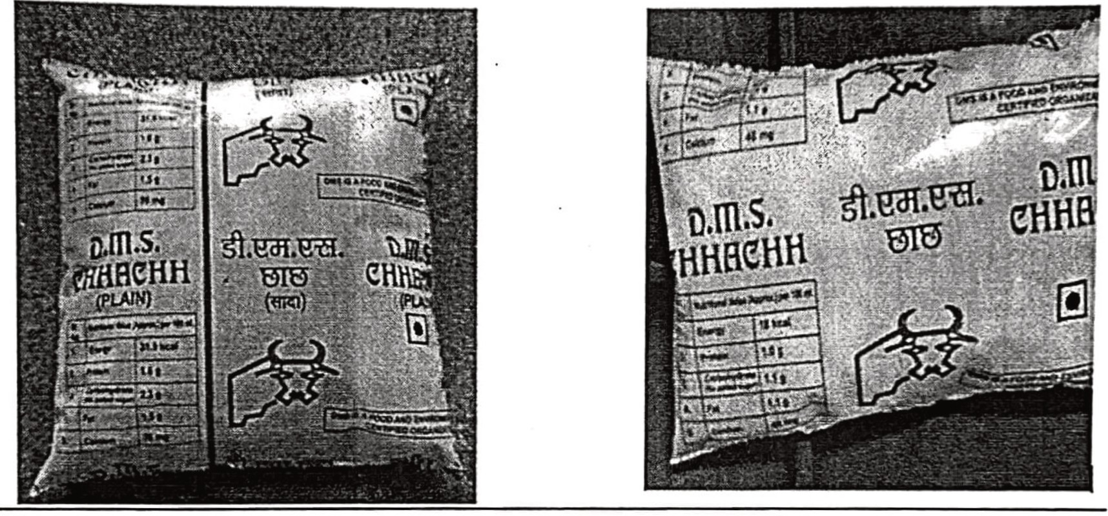

PANEER

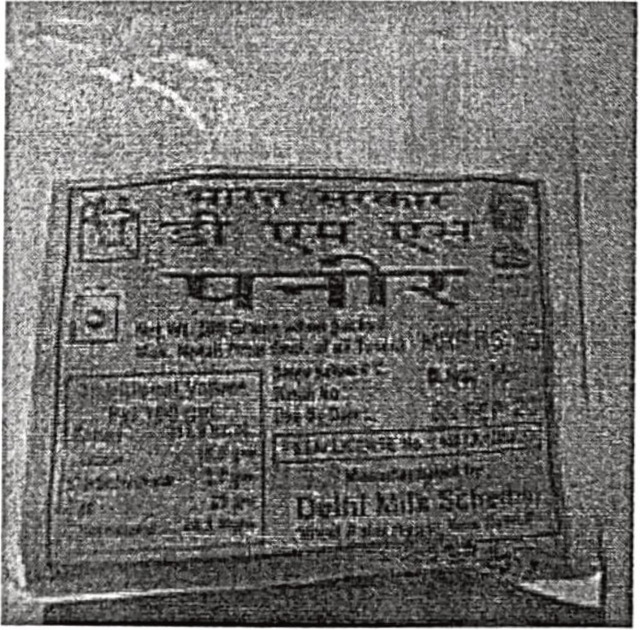

BOILER SECTION

There are two fire tube boilers in OMS.

* + - 1. Rajdeep Boiler

2) IAEc

##### DETAILS OF THESE BOILERS:

Rajdeep -> I] Steam generation capacity {4ton/w) 2] Working Pressure (10.54 kglcm2)

IAEC -> I] Steam generation Capacity *( 5* Ton/hr) 2]Working Pressure (8 kglcm2)

Mounting Points of each Boiler: 1] Spring Loaded safety valve 2]Water Label indicator

3] Pressure change 4]Fusible plug S]Blow off cock

6]MRV *I* FEED check valve

3-way boiler -fire in between

Fire goes to side tubes for gas toward the end 4 out of the chimney. The water meter level adjustS the amount of H20 to the level

2 Tmes of boilers -Fire Tube1 Water Tube

4 ton -fire tube and 5

I Water level

l ton- fire tube

I Pump will•get a signal l

I It will send•to machine l

[ H20 is preserved till •desired level is reached l

###### 25

REFRIGERATION SECTION:

One of the most critical steps in the processing of milk is storage. Milk demands storage at a low temperature not exceeding 5.0 - 6.0 °C. Due to high water activity, and nutrient composition, milk is highly susceptible to microbial spoilage at elevated temperatures.

Psychrotrophs are the class of bacteria concerned, along with moulds and yeast species.

•

The storage temperatures of .5 - 5.5 °c are achieved using .a refrigerant that undergoes a

constant refrigeration cycle to produce a refrigeration effect. The refrigerant used in DMS is ammonia due to its economical nature and low evaporation temperature.

#### The component of a refrigeration cycle is as follows -

-+ Major components of a simple mechanical vapour compression refrigeration system are shown in the figure. As the refrigerant flows through these components its phase changes from liquid to gas and then back to liquid. At location D in Figure, before or to the entrance to the expansion valve, the refrigerant is in a saturated liquid state. It is at or below its condensation temperature. The expansion valve separates the high-pressure region from the low-pressure region. After passing through the expansion valve, the refrigerant experiences pressuredropure accompanied by a drop in temperature. Due to the pressure drop, some of the liquid refrigerant changes to a gas. The liquid/gas mixture leaving the expansion valve is termed "flash gas." ·

-+ The liquid/gas mixture enters the evaporator coils/cooling coils at location E. Inthe evaporator, the refrigerant completely vaporizes to gas by accepting heat from the media surrounding the evaporator coils.

-+ The saturated vapours enter the compressor at location A, where the refrigerant is compressed to high pressure. This high pressure must be below the critical pressure of the refrigerant and high enough to allow condensation of the refrigerant at a temperature slightly higher than that of commonly available heat sinks, such as ambient air or well water. Inside the compressor, the compression process of the vapours occurs at constant entropy (called an isentropic process). As the pressure of the refrigerant increases, the temperature increases, and the refrigerant becomes superheated as shown by location B.

-+ The superheated vapours are then conveyed to a condenser. Using a water-cooled condenser in DMS, the refrigerant discharges heat to the surrounding media. The refrigerant condenses back to the liquid state in the condenser as shown by location D. After the entire amount of refrigerant has been converted to saturated liquid, the temperature of the refrigerant may decrease below that of its condensation temperature due to additional heat discharged to the surrounding media; in other words, it may be subcooled. The subcooled or saturated liquid then enters the expansion valve and the cycle continues.

Hl··H.-

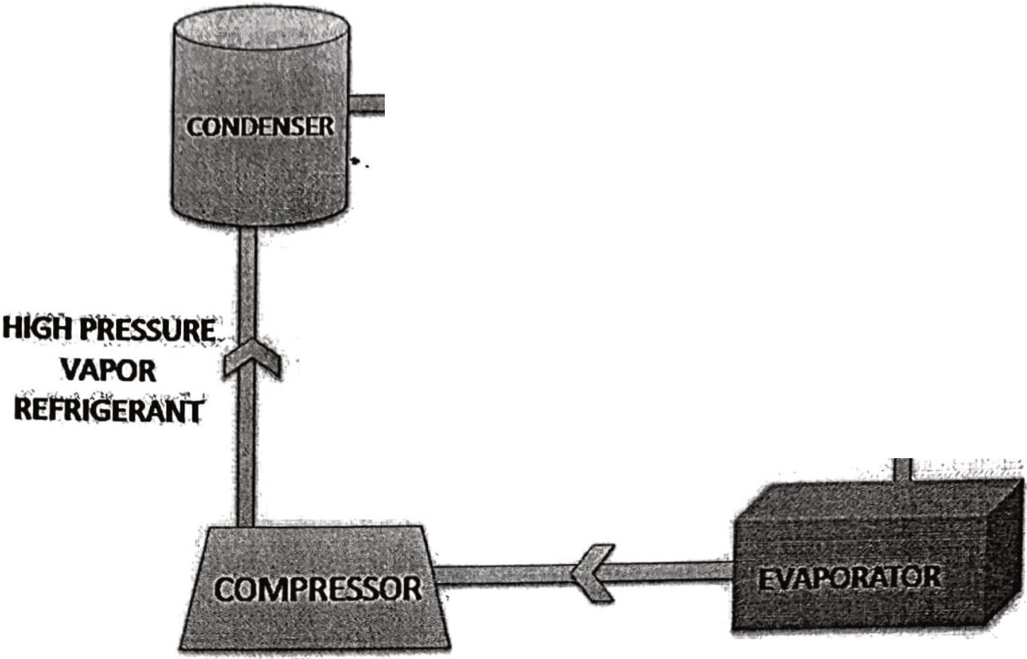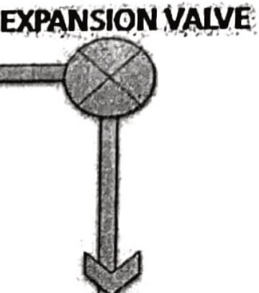

-u.....nH1•Ql:'Jl.t>.

REFRIGERANT

• •

**snWIPL:E**

**IEFRl:G:IJtATtll·**

**(Y:(tE**

lOW PIJ.RE·VAOOR

REFRIGERANT"

components of a refrigerant cycle

*·*•*t{*I*:J*,*·· " ..* • . "**' f**n**t**.**.I**,**:**.

L - ,, .· .. .

UQ.lJl!E.YAPOR

### liEfiijGjiWfr

1. Evaporator - Inside the evaporator, the liquid refrigerant vaporizes to a gaseous state. The change of state requires latent heat, which is extracted from the surroundings (cold storage room).
2. Compressor - The refrigerant enters the compressor in a vapor state at low pressure and temperature. The compressor raises the pressure and temperature of the refrigerant. It is due to this action of the compressor that heat can be discharged by the refrigerant in the condenser. The compression processes raise the temperature of the refrigerant sufficiently above the ambient temperature surrounding the condenser so that the temperature gradient between the refrigerant and the ambient promotes the

heat flow from the refrigerant to the ambient. A reciprocating type of compressor is used in DMS for this purpose.

1. Condenser - The function of the condenser in a refrigeration system is to transfer heat from the refrigerant to another medium, such as air and/or water. By rejecting heat,

the gaseous refrigerant condenses to the. liquid inside the condenser. A water-cooled system is used in the dairy, where the water talces up the heat from the refrigerant to condense it.

1. Expansion valve - An expansion valve is essentially a metering device that controls the flow of liquid refrigerant to an evaporator. The valve can be operated either manually or by sensing pressure or temperature at another desired location in the refrigeration system.

###### QUALITY CONTROL LABORATORY SECTION

The Quality Control concepts of the Delhi Mille Scheme are being modified and at every tage, standard quality checks have been introduced. Milk is not accepted at the dairy unless it meets the basic parameters decided for acceptance. The millc is tested at every stage of processing and is not dispatched, unless it meets the standards set as per statutory as well as hyen! , health point of view. T!ie laboratory is fully equipJ>ed with electronic testing equipment to meet the stringent quality parameter. ·

V:-W

[

## RECEIPT l

I

* l

SAMPLING

)[ AD = ][ FAT/SOLIDS )

. -·

[ SENSORYEVALUA11QN

[ CHILLING ) [ PASTBU•RIZATION ]( ST ONIFOR )

•

CLARIFICATION

COMPREHENSIVE 1EST

[

FOR J I

STORAGE ][ m-)

[ CHECK FOR PAT/SNF )[ PACKAGING j[ 1EMP/ACID11Y l

[ ]( • ][ )

GOOD SEALING VOLUME COI.D STOARAGE

CHECKING

[ TEMPERAlURE J[ DELIVERY l FAT/SNF l

###### ADULTERATION TESTS:

* 1. ORGANOLEPTIC TEST: Judging the quality of milk by its taste & smell. The appearance of the surface of the milk and the lid is observed and inspected instantly after removing the lid of the incoming milk can or container any abnormal color of the milk, visible dirt and particles, changes in viscosity, etc. are observed any foul smell is noticed by inhalation of air standing above the milk in the upper part of the milk then milk is not pure.

Procedure:

O Open a can of milk. Smell the milk immediately .

D Observe the appearance of the milk.

O In case the grader is unable to make a clear dcision about the quality of milk, then taste.the milk.

D Look at the lid and the container to check its cleanliness.

###### Abnormal smell and taste may be caused by:

1. Atmospheric smell (methane, barny or cowy odor).
2. Physiological smell in the animal body that might be due to hormonal imbalance, cows

in late lactation, or spontaneous rancidity of milk.

1. Bacterial products
2. Chemical or bacterial colours in the milk.
3. Advanced acidification (pH < 6.4).

Precaution: Do not swallow but spit the·milk sample into the specified container. Milk suppliers may add some desensitizing chemicals for the grader.

2. CLOT ON BOILING: COB is carried out to check the heat stability of milk. Milk curdles on boiling if the acidity is high., this test is used for rapid testing of increased acidity in milk. Heating will precipitate proteins of milk if it is sour. This method is slower than an alcohol test but very useful where and when an alcohol test is not available. The result can be seen immediately. If no coagulation occurs, it indicates that milk can stand heating operations at the time of testing.

###### Materials required:

1. Test tube

1. Test tube holder
2. Milk sample
3. Bunsen burner or spirit lamp

5. Matches

###### Procedure:

0 Take a 5 ml milk sample in a test tube.

0 Hold the tube with a test tube holder.

O Boil the milk sample in the test tube on the burner for 5 minutes.

Clotting or coagulation of the sample in the tube indicates the failure of the sample to

C.O.B test.

This test may fail to detect the quality if:

1. Freshly drawn milk is contaminated with bacteria.
2. Acidity of the sample is below 0.20-0.26% lactic acid.
3. Milk is contaminated by non-acid-producing bacteria.

3. ALCOHOL TEST: The alcohol test is used on fresh milk to indicate whether it will coagulate during thennal processing. This test is especially important for the manufacture of UHT milk, evaporated milk, and milk powders. This test is more sensitive than Clot-on Boiling (COB) test. It is based on the tendency of milk protein to get unstable as a result of a disturbance in the mineral balance of milk.

###### Materials req uired:

I. Test tubes

1. Ethyl alcohol
2. Pipette

###### Proced ure:

• pt_ :

D Take 2 ml of milk in a test tube.

D Add 2 ml ethyl alcohol.

D Mix well and observe flakes.

D · If there are no flakes alcohol test is negative.

D The presence of flakes shows alcohol test is positive and that the milk is unstable.

1. METHYLENE BLUE REDUCTION-TEST: Methylene Blue Dye Reduction Test, commonly known as MBRT test is used as a quick method to assess the microbiological quality of raw and pasteurized milk. This test is based on the fact that the ble colo of the dye solution added to the milk getsdecolourizedd when the oxygen present 1 th mil!' gets exhausted due to microbial activity. The sooner the colourizationthe menor is e bacteriological quality of milk assumed to be. This test is widely used at the dairy rton dock, processing units, and milk chilling centres where it is followed as acceptance/re3ection criteria for raw and processed milk.

###### Materials required:

1. Sterilized test tubes with rubber stoppers
2. Test tube stand

3. Milk sample

1. Methylene blue solution

*5.* Water bath (37 "C).

6. Thermometer

###### Procedure:

0 Transfer 10 ml of the milk sample into both tubes.

0 Add 1 ml methylene blue solution to the first test tube, noting the time, then place the stopper on the test tube and shake it until the blue colour mixes thoroughly with

the . milk sample.

0 Place both tubes in a water bath at 37 °C.

0 Check them every half an hour for the first two hours and once an hour after that.

0 Ifthe blue colourant disappears in streaks.

0 Gently mix the sample. Ifmilk containing methylene blue becomes white a5 that of milk without methylene blue, the test is over.

0 Note the time it takes to disappear the colour.

0 Record your observations.

1. STARCH TEST: Milk contains a relatively large amount of fat. The addition of bohyrates to mJk increases its solid conten. Thereby reducing the amount of fat present

m the milk. Starch 1s one such component that 1s added to adulterate milk. The test to detect starch in milk uses an iodine solution, the addition of which turns the milk solution to a blue­ black colour or due to the formation of starch-Iodo complex, in the presence of starch.

###### Materials required:

1. Test tube

1. Gas burner/Spirit lamp
2. I 0 ml graduated pipette
3. I % Iodine solution (in alcohol)

###### Procedure:

D Take a 3 m well-mixed sample.

30